**Stats Lecture 4**

**Continuous Probability Distribution**

**Continues Random Variable**

**P ( a <= x <= b)**

a= lower limit

b= Upper limit

x= count of all the possible outcome between a and b

**Graphs or formulas are used to represent continues distribution**

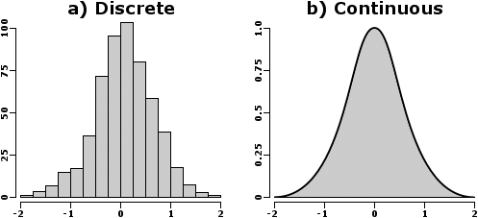

**In continues probability function area under curve always = 1**

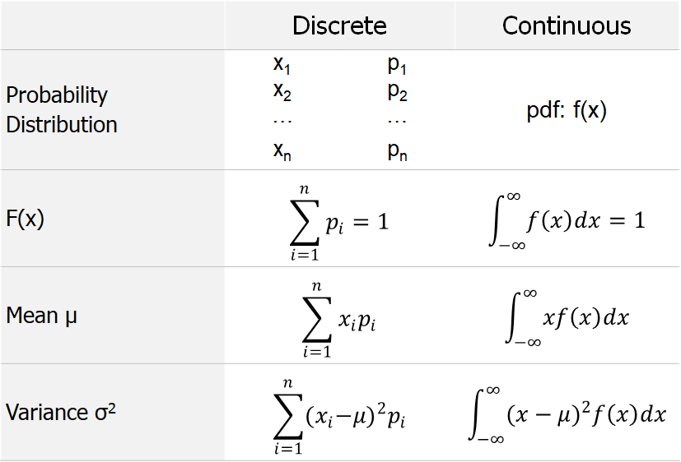

**Examples from the Note Book**

**Uniform Probability Distribution**

**A continues random variable x is said to follow a continues uniform or rectangular distribution over interval (a, b) if its pdf is given by**

�(�)={1�−�for �≤�≤�,0for �<�  or  �>�. 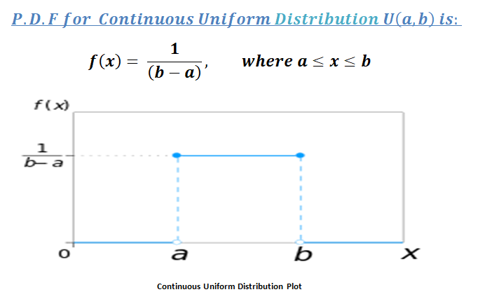

After that use book: - For Examples

For mean and variance